**Teacher Instructions for Student Enrollment Reconciliation**

The Texas Education Agency requires all districts to reconcile student membership from the teacher’s roster to the attendance accounting records in the Student Information System. This reconciliation is to verify that all students are reported on attendance records and that no-show students have been purged from the Student Information System.

Houston I.S.D. will perform this task on **Wednesday, October 14, 2020.**

The total number of students in membership is to be reconciled to the total number of students listed on the teacher’s class roster. Each teacher will certify their class roster with their signature.

Instructions:

**Step 1:** Teachers please strike a single line thru the student’s name if the student never engaged in your class this school year. Write No Show in the comment section.

**Step 2:** Teachers please tally total number of students engaged in your class this school year. Note: Absent students are still counted in membership.

**Step 3:** Teachers please sign and date the top of your roster and submit it to your S.I.R/Clerk.

**SIR/Attendance Clerk Instructions**

**Student Enrollment Reconciliation**

The Texas Education Agency requires all districts to perform a reconciliation of teacher rosters to the student attendance accounting system. The district has chosen to perform this task on October 14, 2020 to ensure accurate data is maintained in the Student Information System.

Student membership from the teacher’s roster is to be reconciled to the attendance accounting records in the Student Information System. This reconciliation is to verify that all students are reported on attendance records and that “No-Show” students have been purged from the student accounting system.

Houston I.S.D. has assigned the date below in which this process will take place on

**October 14, 2020.**

**Step: 1** Distribute Class Rosters and instructions to all **ADA** teachers.

**Step: 2** Create an ADA teacher roster to use as a check off list to ensure all teachers have returned their Class Roster. Confirm that teachers no showed students, totaled, signed and dated the roster.

**Step 3**: Look at attendance screen for each student marked as No Show. If the **student engaged** in another class **do not** **No Show** the student. If the **student did not engage** in any class mark the student, **No Show.**

**Step 4**: Run an Entry/Exit Report in Excel and document students who the teacher struck through and you did not no show because the student engaged in a non-ADA period. For example, M. Tejada was marked “RA Present” in 6th period and No Showed by the ADA period teacher. The PEIMS Coordinator must sign and date this report.

**Step 5**: Run the Enrollment Summary Report – This will provide a total count of students

[Start Page](https://hisdconnect.houstonisd.org/admin/home.html) > [PSCB Custom Reports](https://hisdconnect.houstonisd.org/admin/reports_pscb/pscb_home.html) > [Enrollment](https://hisdconnect.houstonisd.org/admin/reports_pscb/pscb_enrollment.html) > Enrollment Summary -Enrollment Selected Date

**Step 6**: Total membership count and enter that information on the Campus Membership Reconciliation form.

(Note, your manual count and the enrollment summary totals should be the same)

**Reconciliation for your campus is due to the**

**PEIMS Coordinator on or before**

**Tuesday, October 20, 2020**

Please scan and email copies of Teacher Rosters, Excel Document, and the Campus Membership Reconciliation Form to the Federal and State Compliance Department by Wednesday, October 21, 2020.

Directions to run Reports in HISD Connect

And

Sample Reports and Forms

**Elementary Class Attendance Audit/Class Roster**

1. On the Start Page of PowerSchool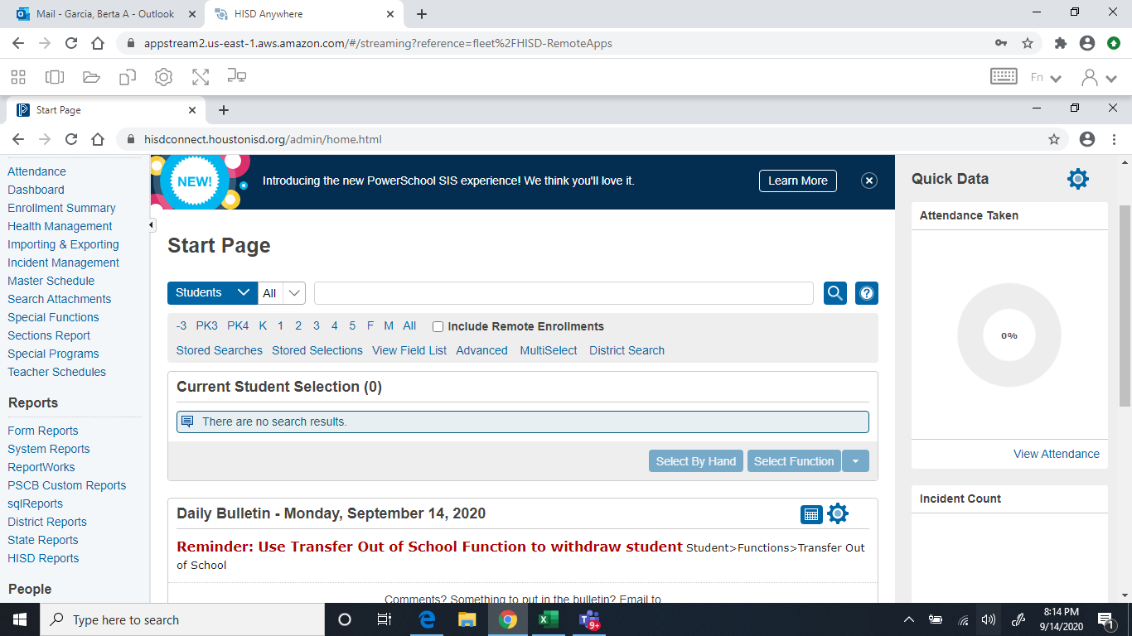
2. Under Reports select System Reports

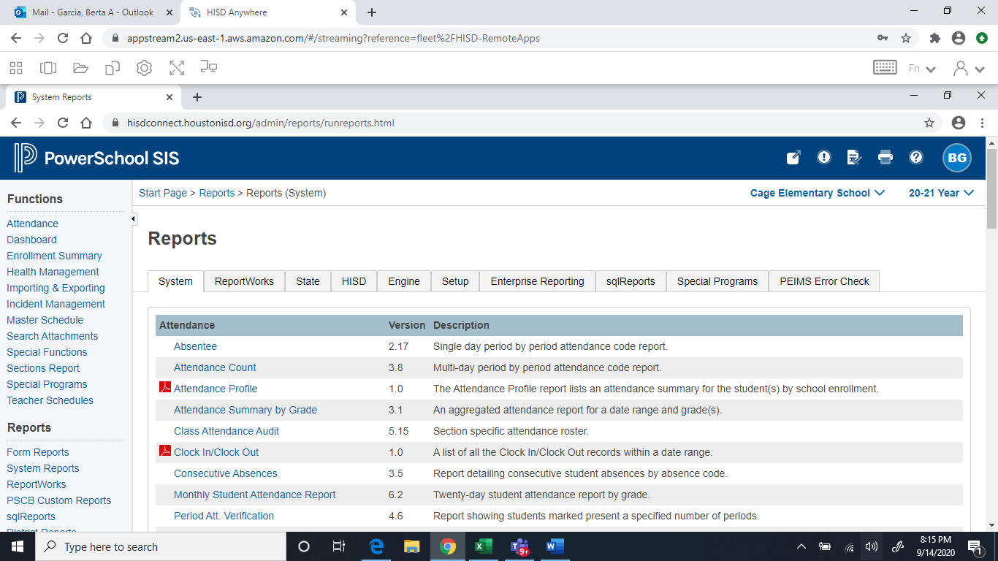

1. Select Class Attendance Audit
2. Reporting Segment: Use default Cycle I

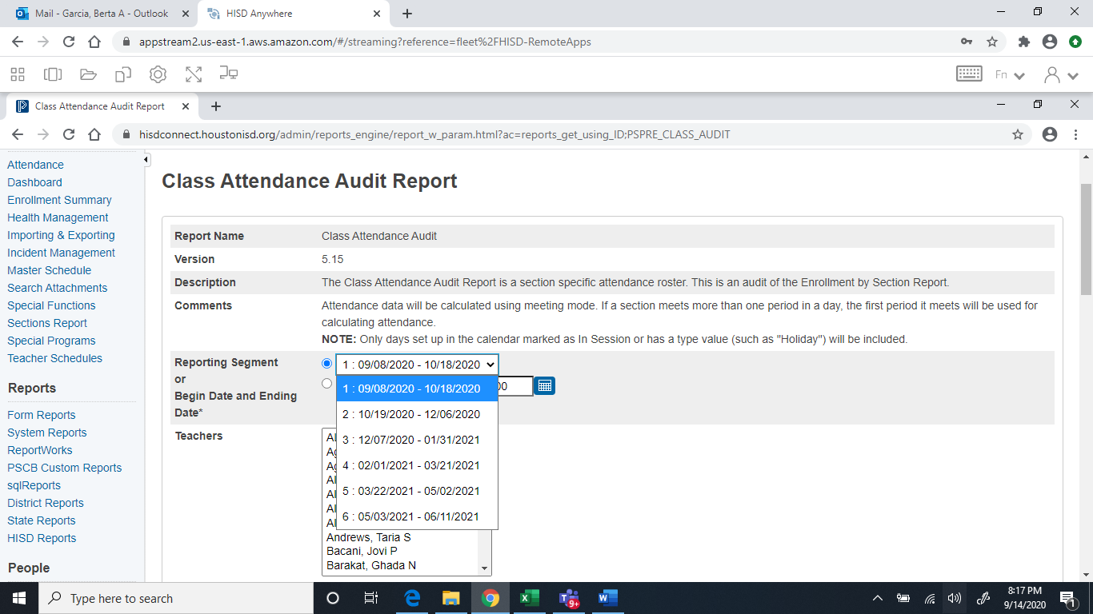

1. Select All Teachers Check Homeroom box

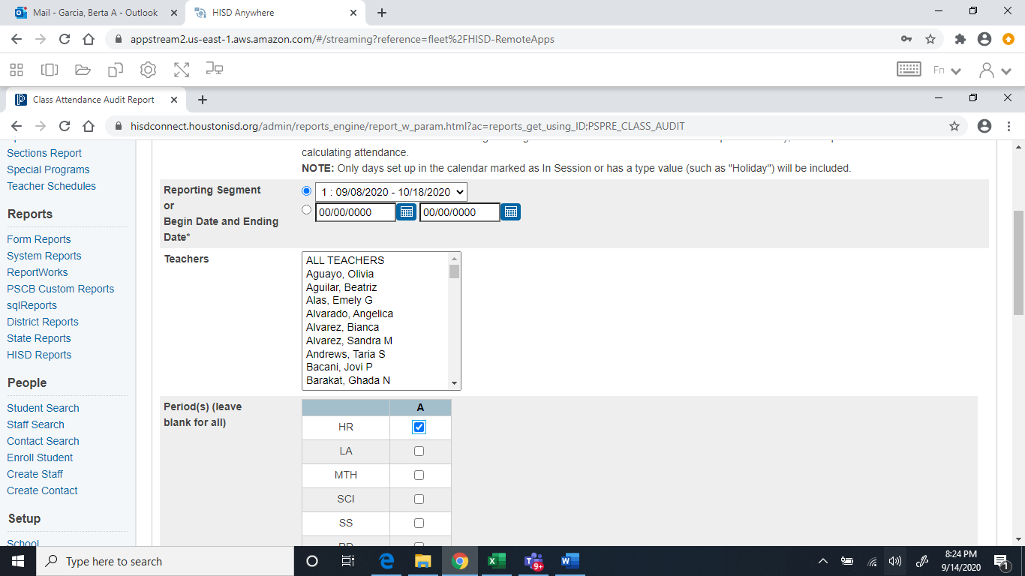

1. Include Student Number - Check the box so student ID# will appear on report.

Type Teacher signature, membership count, date and lines in Header Fields

Header Label 1 Type Teacher Signature: ________________________________

Header Label 2 Type: Membership Count: __________ Date: ______________

Leaving everything alone it will print Landscape.

Click Submit button.

Go to your Report Queue on top on the page. Refresh if needed.

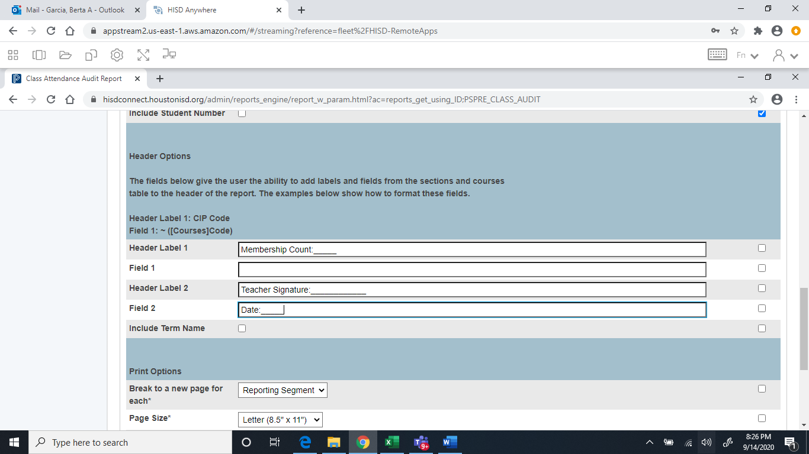

**Sample Elementary Class Attendance Audit/Class Roster**

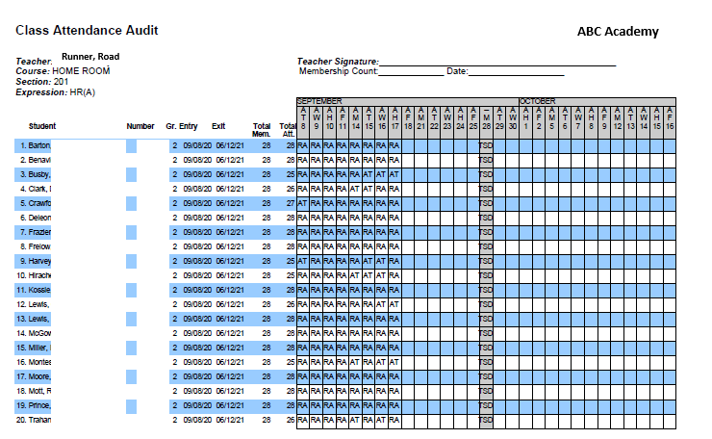

**Secondary Class Attendance Audit/Class Roster**

On the Start Page of PowerSchool



Under Reports select System Reports

Select Class Attendance Audit



Reporting Segment: Use default Cycle I



Select All Teachers

Click on your ADA period. A Day and B Day Check ADA Period

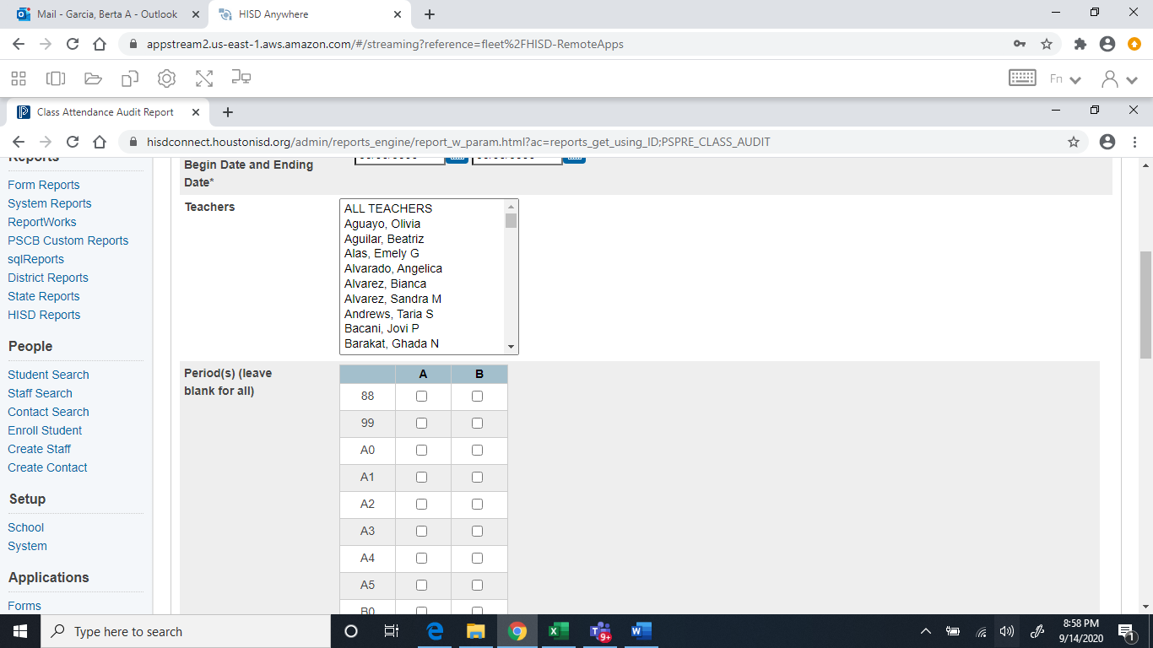

Include Student Number - Check the box so student ID# will appear on report.

Type Teacher signature, membership count, date and lines in Header Fields

Header Label 1 Type Teacher Signature: ________________________________

Header Label 2 Type: Membership Count: __________ Date: ______________

Leaving everything alone it will print Landscape.

Click Submit button.

Go to your Report Queue on top on the page. Refresh if needed.



**Sample Secondary Class Attendance Audit/Class Roster**

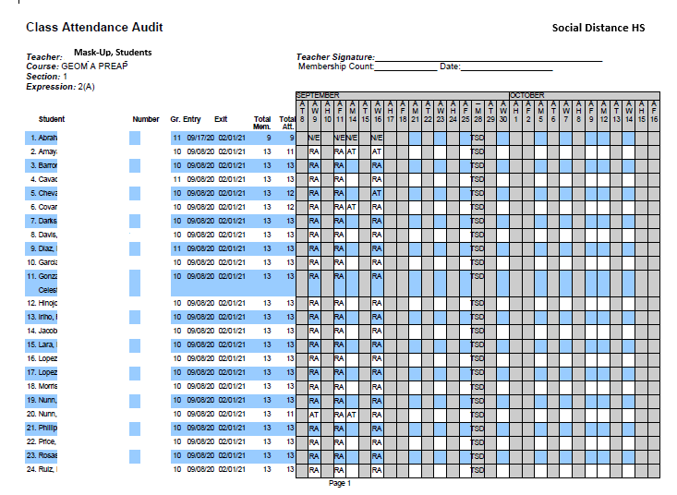

**Search-Student Entry/Exit Summary Report**

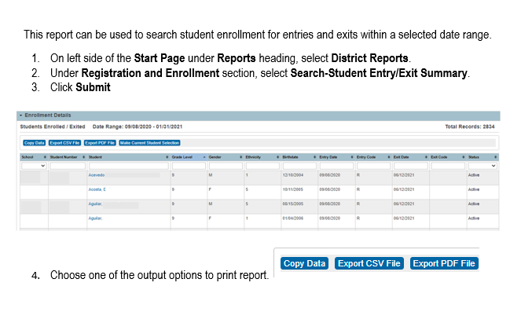

**Sample Excel Document**

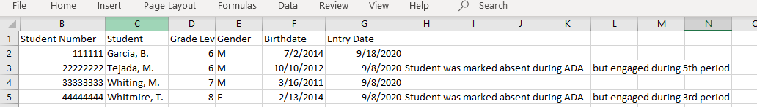

**Enrollment Summary Report**

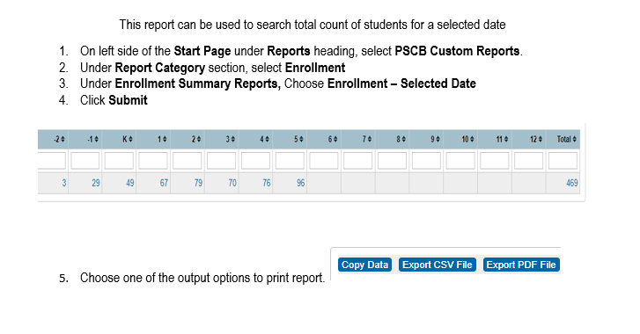

**Sample Teacher Class Log**

|  |  |  |  |  |  |  |
| --- | --- | --- | --- | --- | --- | --- |
| 1st Six-Week Teacher Reconciliation Teacher Count Sheet Date: _____________ | | | | | | |
|  |  |  |  |  |  |  |
| Teacher Name | Rec'vd | Hd Count | Teacher Name | Rec'vd | Hd Count |  |
| Brown | $$√$$ $$√$$ $$√$$ $$√$$ | 14 |  |  |  |  |
| Bunker | 30 |  |  |  |  |
| Davis | 27 |  |  |  |  |
| Fowler | 27 |  |  |  |  |
| Washington | $$√$$ | 12 |  |  |  |  |
|  |  |  |  |  |  |  |
|  |  |  |  |  |  |  |
|  |  |  |  |  |  |  |
|  |  |  |  |  |  |  |
|  |  |  |  |  |  |  |
|  |  |  |  |  |  |  |
|  |  |  |  |  |  |  |
|  |  |  |  |  |  |  |
|  |  |  |  |  |  |  |
|  |  |  |  |  |  |  |
|  |  |  |  |  |  |  |
|  |  |  |  |  |  |  |
|  |  |  |  |  |  |  |
|  |  |  |  |  |  |  |
|  |  |  |  |  |  |  |
|  |  |  |  |  |  |  |
|  |  |  |  |  |  |  |
|  |  |  |  |  |  |  |
|  |  |  |  | Total | 110 |  |
| Campus Daily Register Totals: | | |  |  |  |  |
| Grade | 6 | 60 |  |  |  |  |
|  | 7 | 30 |  |  |  |  |
|  | 8 | 20 |  |  |  |  |
|  | Totals | 110 |  |  |  |  |

**Sample Campus Membership Reconciliation Form**

